Driving Behavior Analysis using Deep Learning
🔹 1. Introduction
This project focuses on building an intelligent deep learning system that analyzes sensor data collected from a smartphone and evaluates driving behavior by assigning a driving score.
🔹 2. Project Objective
The main objectives of this project are:
- Analyze driving behavior using motion sensor data
- Build deep learning models to learn driving patterns
- Classify driving into categories (1 to 5 stars)
- Generate a Driving Score / Risk Score
- Provide human-readable feedback about the driver
🔹 3. Dataset Description
The dataset is collected using an Android application that records motion sensor data.
Each data sample contains:
- Accelerometer: X, Y, Z axes
- Gyroscope: X, Y, Z axes
- Timestamp information
The dataset is organized into five categories:
- 1 Star → Dangerous driving
- 2 Star → Rash driving
- 3 Star → Normal driving
- 4 Star → Good driving
- 5 Star → Excellent driving
The dataset includes real-world variations such as:
- Multiple riders
- Different riding styles
- Different speeds
- Different road conditions
- Different phone placements
🔹 4. Methodology
4.1 Data Preprocessing
- Removal of unnecessary columns
- Handling missing values
- Sorting time-series data
- Removing redundant/static sensor readings
- Handling outliers
4.2 Feature Engineering
To better represent driving behavior, the following features were created:
- Acceleration magnitude (overall motion intensity)
- Gyroscope magnitude (rotation intensity)
- Jerk (sudden change in motion)
- Rolling statistics (smoothness of driving)
- Variance (stability of driving behavior)
These features help distinguish between aggressive and smooth driving.
4.3 Time-Series Modeling
Driving data is sequential in nature. Instead of using individual readings, sequences of sensor data are used to capture behavior over time using sliding window techniques.
4.4 Model Development
Three deep learning models were developed:
- LSTM (Long Short-Term Memory)
- GRU (Gated Recurrent Unit)
- Transformer (Attention-based model)
Each model was trained to classify driving behavior into 5 categories.
🔹 5. Model Evaluation
Models were evaluated using:
- Accuracy
- Training & validation curves
- Confusion matrix
📊 📌 Graph 1: Final Model Comparison
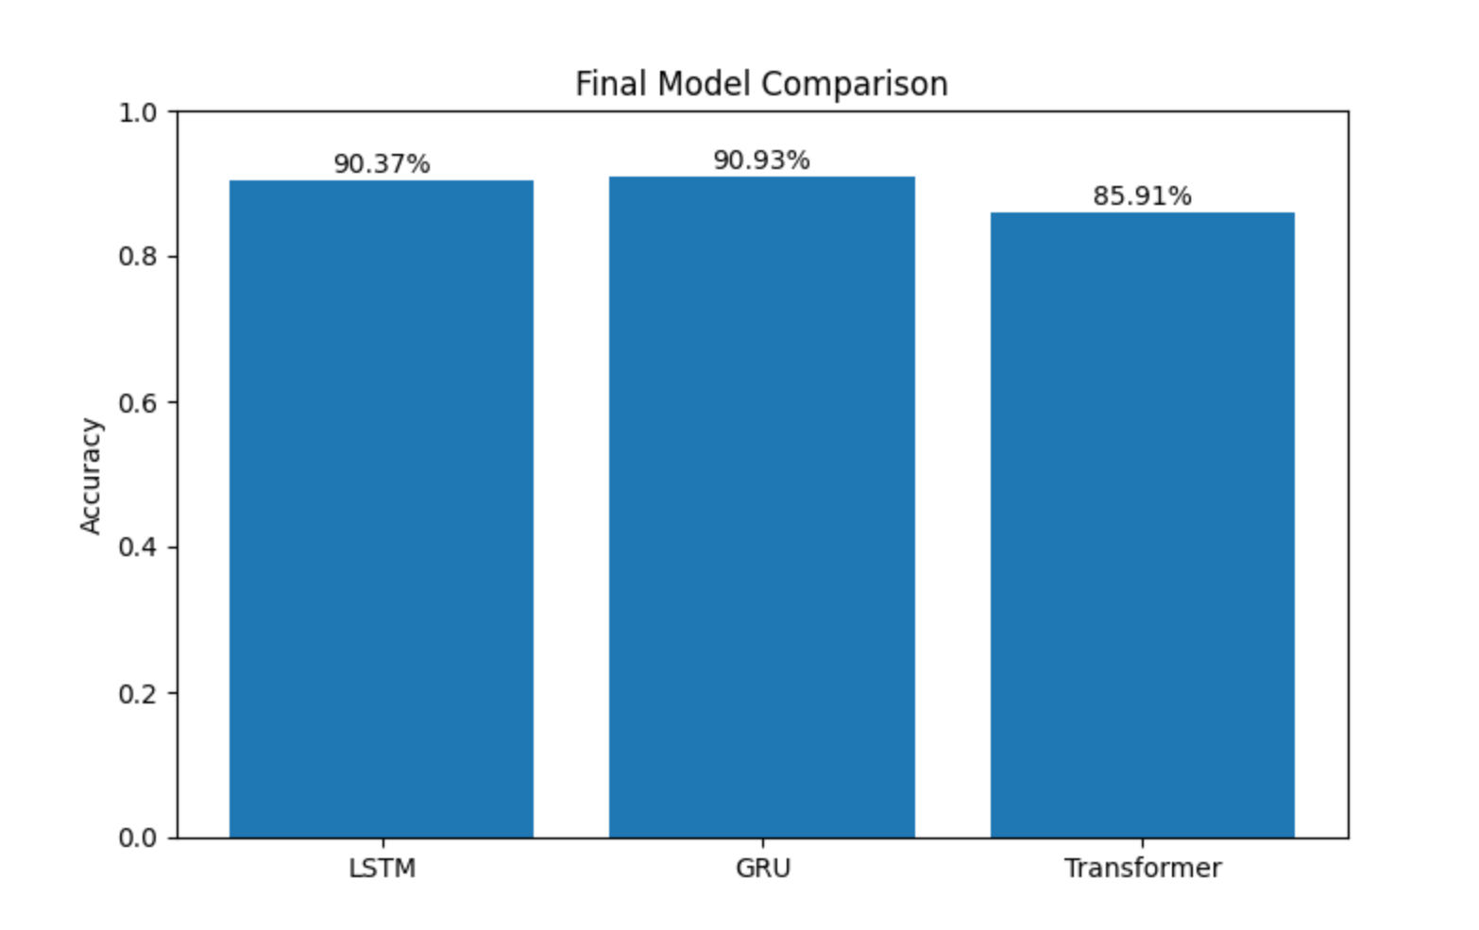
📌 Explanation:
- GRU achieved the highest accuracy (~91%)
- LSTM performed slightly lower (~90%)
- Transformer showed lower accuracy (~85%)
This confirms that GRU is the best-performing model.

📊 📌 Graph 2: Validation Accuracy Comparison
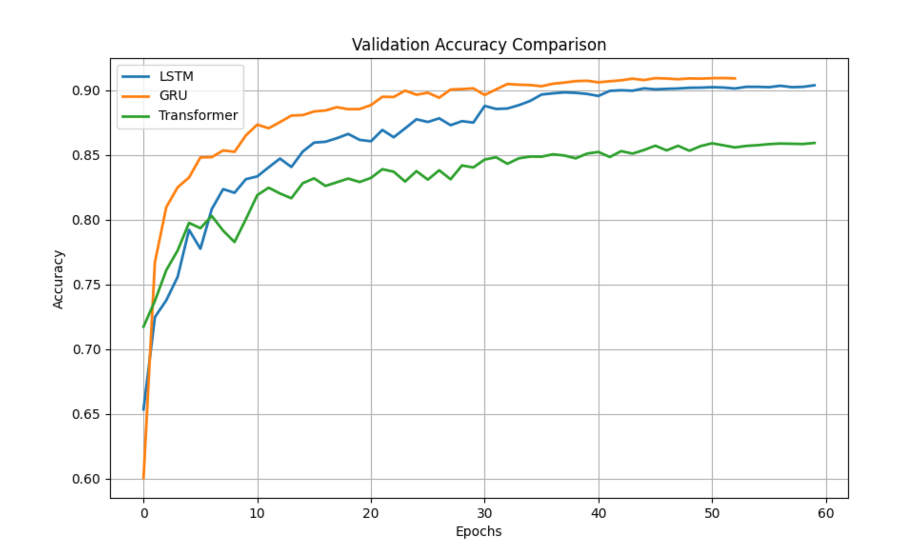
📌 Explanation:
- GRU converges fastest
- LSTM is stable but slightly slower
- Transformer learns slower and fluctuates more
🔹 6. Driving Score System
The system outputs a driving score:
- 1 → Dangerous
- 2 → Rash
- 3 → Normal
- 4 → Good
- 5 → Excellent
It also provides human-readable feedback such as:
- Safe driver
- Moderate driver
- Risky driver
🔹 7. Model Trustworthiness
The reliability of the system is evaluated based on:
- Consistent performance across models
- Stable training and validation accuracy
- Confusion matrix analysis
📊 📌 Graph 3: Train vs Validation (Overfitting Check)
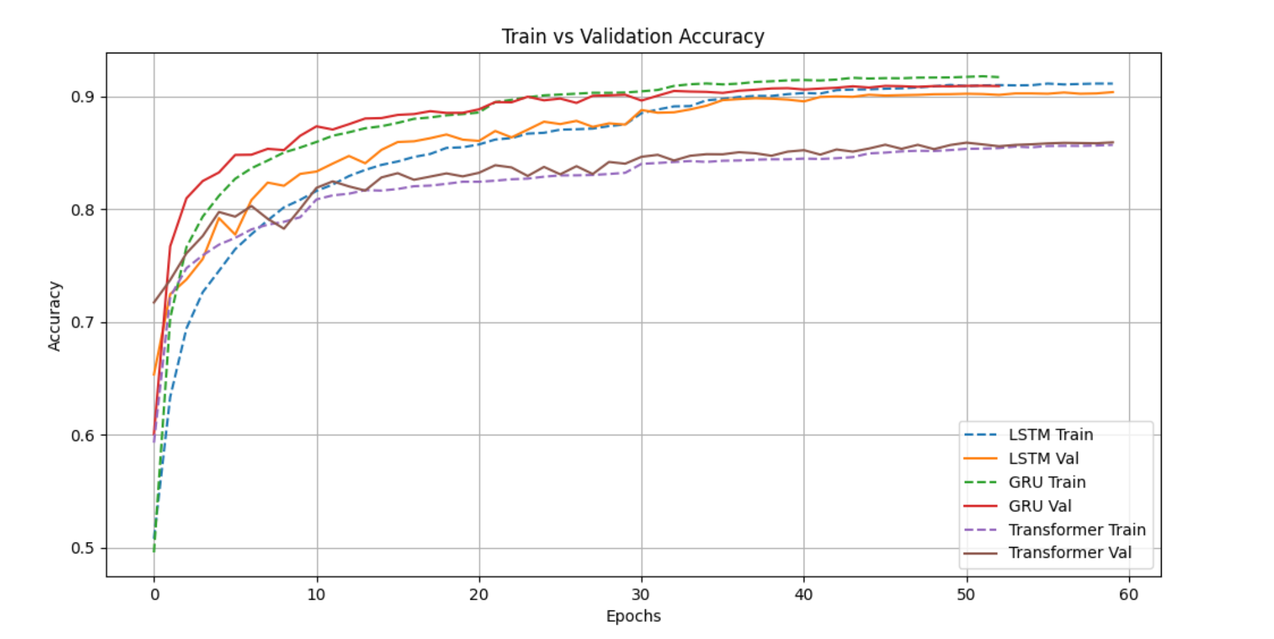📌 Explanation:
- Training and validation curves are close
- No major overfitting observed
- Models generalize well

📊 📌 Graph 4: Confusion Matrix (Best Model - GRU)
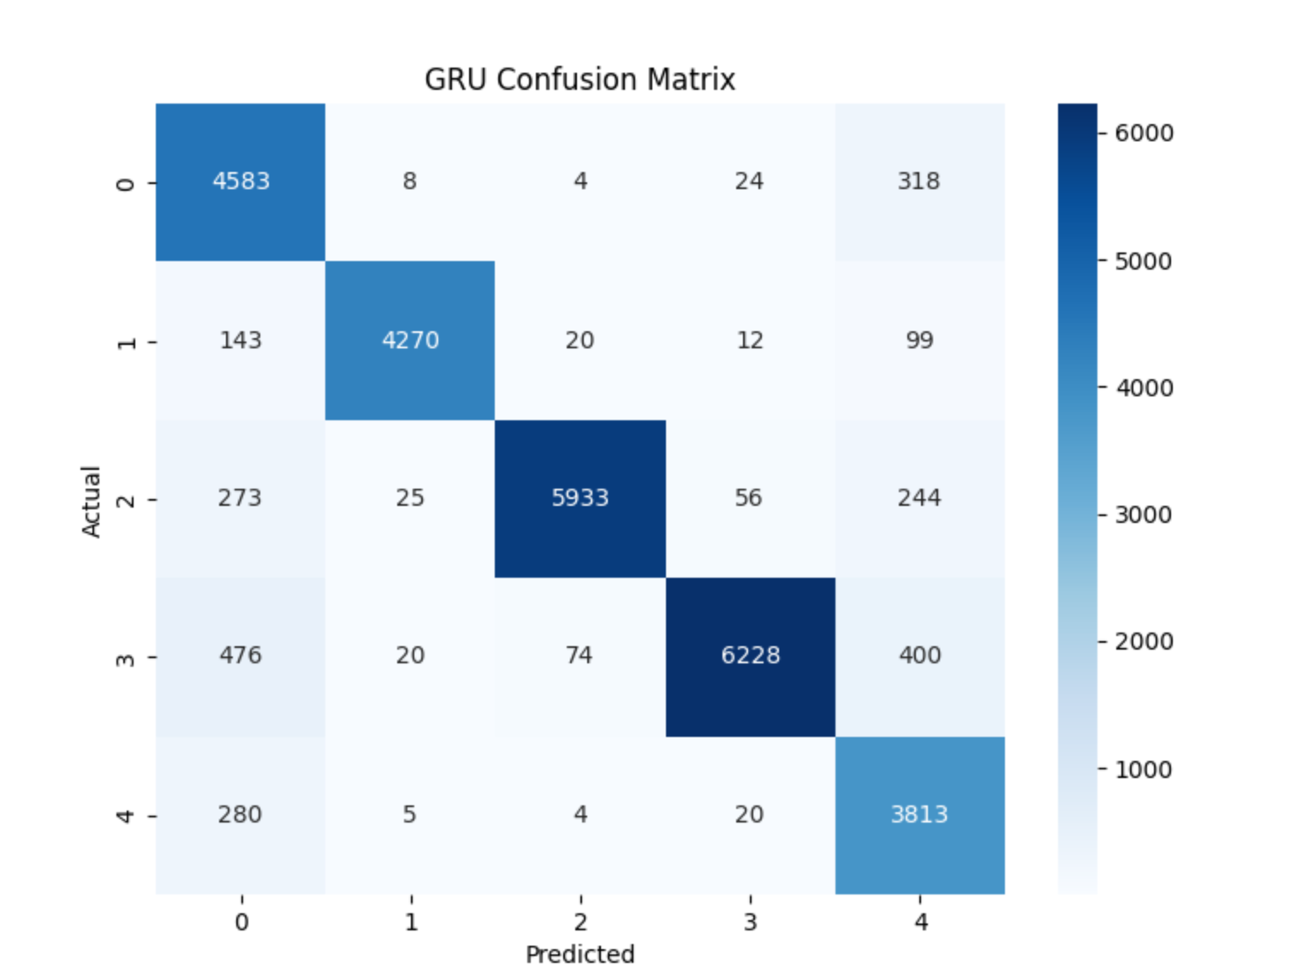
📌 Explanation:
- Strong diagonal values → correct predictions
- Minor confusion between nearby classes (3 & 4, 4 & 5)
- Model captures relative driving behavior effectively
🔹 8. Limitations
- Sensor noise may affect predictions
- Phone placement impacts readings
- Similar driving styles may overlap between classes
Using multiple models improves robustness.
📄 ✅ BONUS SECTION
Comparison of RNNs vs Transformer for Driving Behavior Analysis
🔹 1. Introduction
This section compares different deep learning architectures for time-series driving data.
Models compared:
- LSTM
- GRU
- Transformer
🔹 2. Model Performance (Experimental Results)
- GRU ≈ 91% (Best)
- LSTM ≈ 90%
- Transformer ≈ 85–86%
👉 GRU slightly outperforms LSTM, while Transformer performs lower.
🔹 3. Training Behavior Analysis
From validation accuracy graphs:
- GRU converges fastest
- LSTM shows stable learning
- Transformer learns slower
🔹 4. Loss Analysis
- Training loss decreases smoothly
- Validation loss follows closely
👉 No major overfitting observed
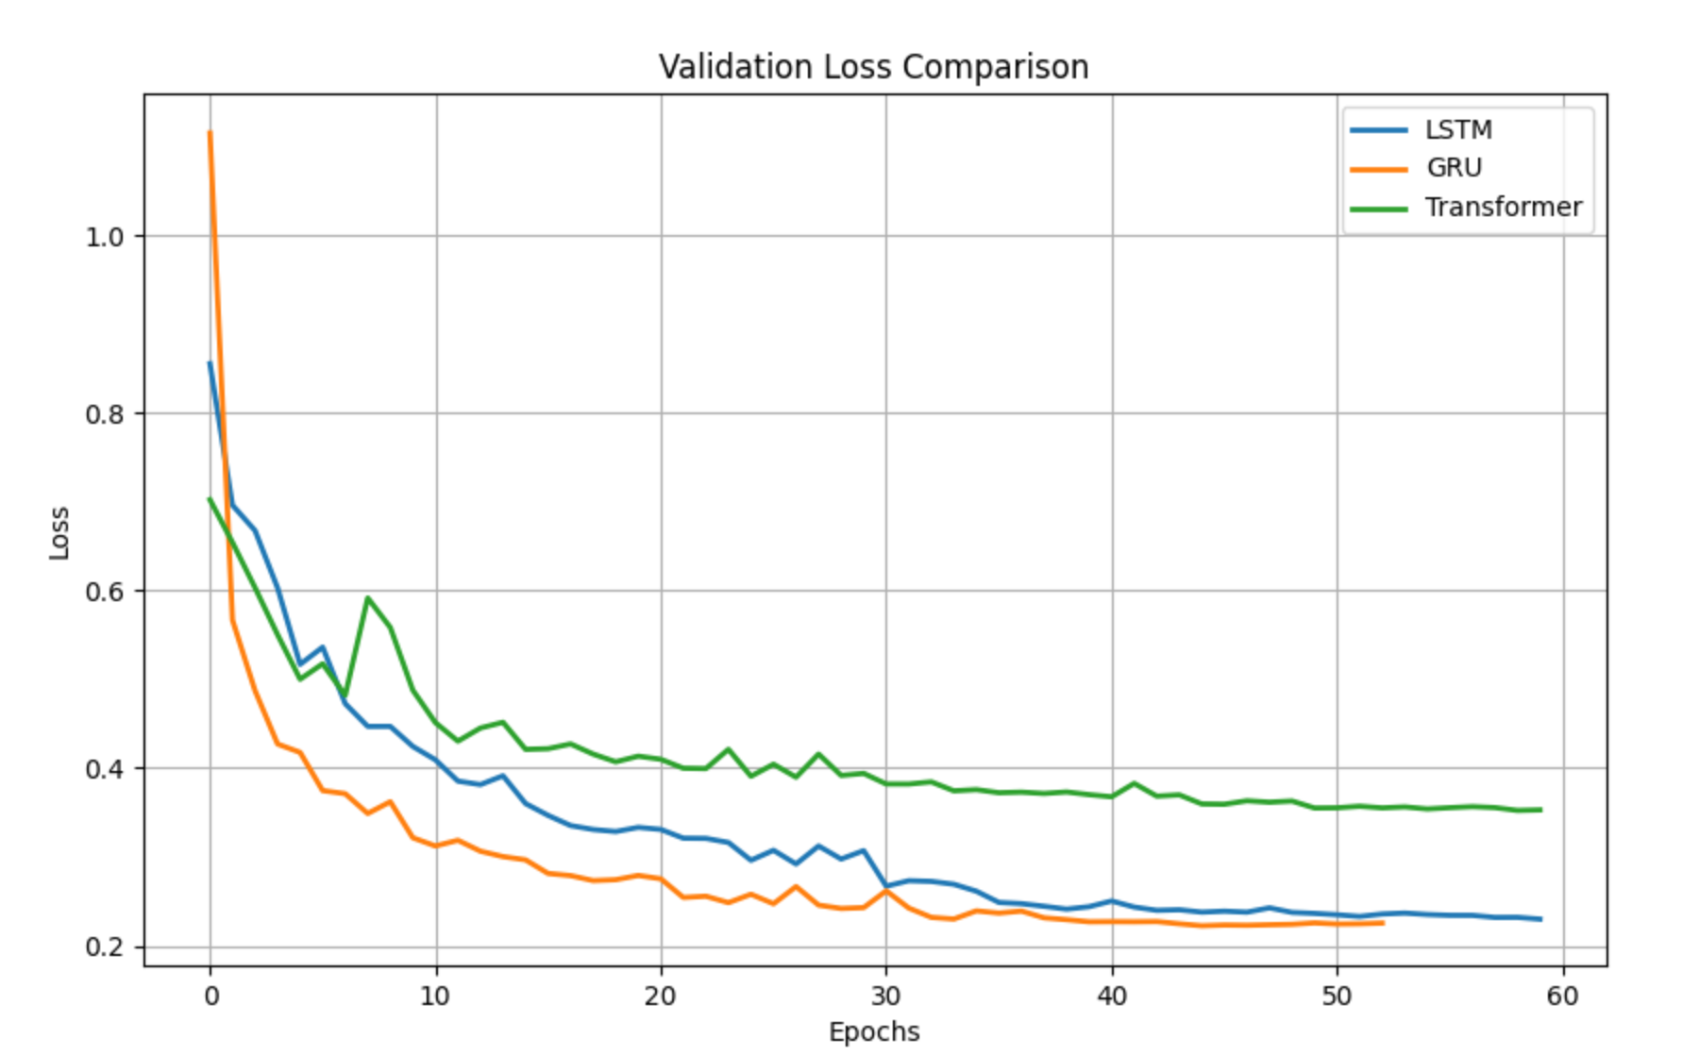
However:
- Transformer has higher loss → weaker generalization
- GRU has most stable loss → best performance
🔹 5. Confusion Matrix Analysis (GRU)
Observations:
- High diagonal values → correct classification
- Minor confusion between similar classes
👉 Model understands driving patterns effectively.
🔹 6. Theoretical Comparison
🔵 LSTM
- Good for long-term dependencies
- Slightly slower training
- High accuracy
🟢 GRU
- Fewer parameters
- Faster training
- Best performance
🟣 Transformer
- Uses attention mechanism
- Needs large datasets
- Performs lower on small datasets
🔹 7. Final Comparison Table
Criteria | LSTM | GRU | Transformer
Accuracy | ~90% | ⭐ ~91% | ~85%
Speed | Medium | ⭐ Fast | Slow
Stability | High | ⭐ Very High | Medium
Overfitting | Low | ⭐ Lowest | Moderate
🔹 8. Key Insights
- GRU performs best due to efficiency and fewer parameters
- LSTM performs well but is more complex
- Transformer requires larger datasets
🔹 9. Final Conclusion
GRU is the most suitable model for this task because:
- Highest accuracy
- Fast training
- Better generalization
- Efficient for time-series data

